Project Proposal

On

**Pharmacy Management System**



Daisyna Shrestha

00172899

Computing Project

Level 5 Diploma in Computing

Softwarica College of IT and E-Commerce

Kathmandu, Nepal

23rd April, 2019

Submitted to: Kiran Rana

Table of Contents

**1.** **Introduction** 2

1.1 Project Introduction 2

**1.2 Justification for project** 3

1.2.1 Background of the project 3

1.2.2 Problem Statement 3

1.3 Description of the project 4

1.3.1 Features 4

2. Project Scope 4

2.1 Scope and Limitation of project 4

**3. Development Methodology** 5

3.1 Methodology used 5

3.2 Design Pattern 6

3.3 System Architecture 7

4. Work Breakdown Structure (WBS) / Scheduling 8

4.1 Work Breakdown Structure 8

4.2 Milestones 9

4.3 Scheduling / Gantt Chart 11

5. Risk Management 12

6. Configuration Management 14

**7. Conclusion of the project** 14

**8. References** 14

# **Introduction**

## **Project Introduction**

In the field of Health care industry, information and communication technology has played a vital role nowadays in order to store data securely and to access them easily in a short period of time. So, I have decided to develop a technically appropriate and user-friendly system for Pharmacy to manage the drugs and consumables in pharmacy unit.

Pharmacy management system is vigorous and technology integrated system. It deals with the management of the medicine and consumable materials for the patients. And I am intending to develop the system that maintains all the sections related to Pharmacy like consumables drugs for patients and its billing system. With the help of this management system, people will get the correct medication with right dosage of medicine. This will boost the productivity of the clinical work and enhance easiness for patient’s medication.

## **1.2 Justification for project**

### 1.2.1 Background of the project

In general, the project am going to develop will be based on web-based application with user-friendly interface that can be used by both pharmacist and the patients. Pharmacist will process the prescription of drug and maintains other Pharmacy related work while patients will be ordering or buying the medicine suggested by their doctors. It will also deal with the automated bill generating task.

The system will be storing details of drugs like its quantity, expiry date, manufactured date, price and other related information. The stocks details will also be maintained. It will also provide customer to log into the system to place their order. This management system will enhance the efficiency of the patient’s ease and makes convenient in accessing data of the medicine, provides security in data input and output. And manual task will be replaced by automated task like manual calculation of medicine will be replaced by automated bill generation which will save time and effort. All the important data will be back up securely in the cloud or other external drive to prevent from potential risk.

### Problem Statement

In the present situation, the medicine stock management is very poor that a pharmacist needs to check the stock time to time manually and documenting the stock details in the paper-based work which has consumed a lot of time. And this makes pharmacist unknown about stock when customer places the order. So, this project will warn about the medicine stock. And the pharmacist will be prepared about order of the medicine that are demanded more by the customer. Also, pharmacist has to calculate their daily financial activities manually which has results error in the budgets.

Another problem is that customer is finding difficulties in selecting the trusted medicine according to their illness as they are unknowingly consuming expired medicine which has affected the health of the customer. Therefore, this system will manage to select the correct medicine for the customer. Also, customer is buying their medicine by visiting to the medicine store and searching their medicine store to store if they do not find them. To minimize these problems and to ease customer ordering, this project is being developed that will maintain time, cost, quality and other necessary requirements of the system.

## **1.3 Description of the project**

### 1.3.1 Features

The features included in the project are as follow;

* Customer and pharmacist registration and login system
* Changing the login password
* Store data of medicine and related information
* Update, edit and delete the medicine information
* Effective search of medicine
* Warn the pharmacist when medicine item is low
* Record the customer orders
* Generate a report of the bill

And other non-functional features are as follow;

* User-friendly
* Reliable
* Good performance
* Independent of working platform
* Secure operation

# 2. Project Scope

## 2.1 Scope and Limitation of project

### Scope:

The scope of the project is limited that will include the stock management, maintain health outcomes with appropriate medicine consumption, enhance access of available medicine in the store and improving the efficiency of the pharmacy. And replacing the manual calculation with automated bill generation.

### Limitation:

The current project will only allow the customer to place their order of the medicine but when the bill is generated, they have to come to store for their payment as the project lacks online payment system.

But this can be updated later with new requirements.

## 2.2 Aims and Objectives

The aims and objectives of the project are as followed;

### Aims

* The aim of the project is to maintain the consumable drugs for the patient, manage the medicine stock and generate an automated bill.

### Objectives

* It provides the user-friendly interface.
* It helps to maintain all the sections related to pharmacy.
* It deals with the automated generating bill of the medicine.
* Safe data input and output, Update, edit and delete medicine information, Fast searching of the medicine.
* Customer can easily place their order.
* Secure and reliable information storage of medicine and customer.
* To enhance the efficiency of the clinical’s work.

# **3. Development Methodology**

## 3.1 Methodology used

I have chosen Waterfall methodology for the development of my project. Waterfall model is the simplest and earliest software development approach to ensure success of project. It is linear-sequential software development model in which development is seen as flowing steadily downwards like a waterfall through phases of requirement analysis, design, implementation, testing, deployment and maintenance. In this model, each phase must be completed before beginning another phase and the phases are not overlapping.

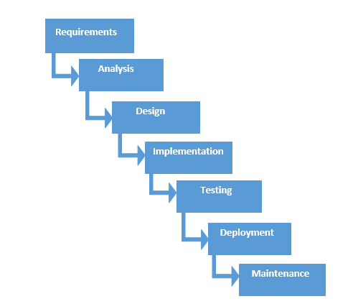

Figure : Waterfall model

And the six phases of water model are as follow;

1. **Requirement analysis**

All potential requirements are analyzed and documented in a proper requirement specification document. This phase describes what the system will do.

1. **Design**

With the input of requirement specification from first phase, overall system architecture is specified such as hardware and software, programming language etc.

1. **Implementation**

The system is then developed using all models, business logic and service integration.

1. **Testing**

Here the implemented system is tested -using unit testing, white box testing, integration testing and other testers- for its functionality. Any failure and faults are identified.

1. **Deployment**

After testing is done, the product is deployed to the customer environment.

1. **Maintenance**

And to keep the system updated and functional, better versions and patches are released in order to fix the bugs identified.

I choose Waterfall model because of the following reasons;

1. As waterfall model is suitable for small projects like mine and it is easy to understand and simple to use.
2. This model works well where the requirements are clear and understandable.
3. Due to its rigidity, it is easy to manage and each phase has specific goals and review process.
4. It helps to measure project milestones.

## 3.2 Design Pattern

I have applied MVC design pattern for system implementation and MVC stands for “Model-View-Controller”. It is design model of three interconnected parts and is widely used for developing user-interface.

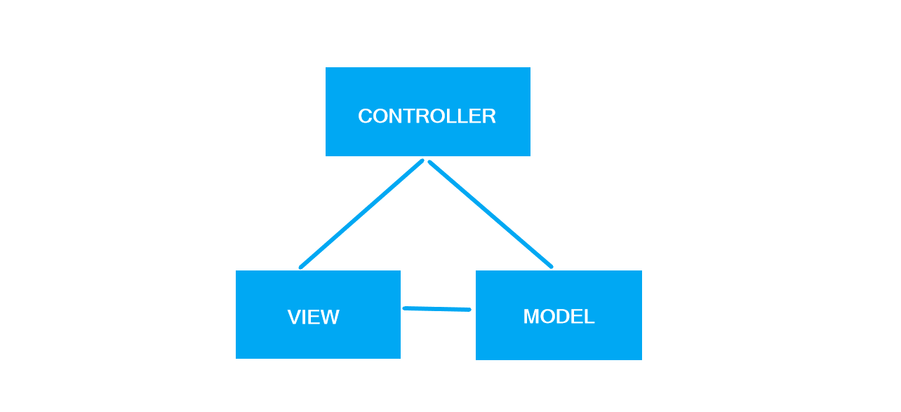

Figure : MVC design pattern

The three interconnected parts includes model, view, and controller. And each component has their own role in MVC design pattern.

1. **Model**

It carries data and can contain business logic used by the program.

1. **View**

It represents the GUI part with which user will interact.

1. **Controller**

It controls the data flow into model and update view. It connects user with the system.

The reason behind choosing MVC design pattern for my project are as follow;

1. Supports fast and parallel development system.
2. Provides multiple views.
3. Less code duplication as data and business logic is separated.
4. Modification can be done easily that changes won’t affect entire model.
5. Supports for asynchronous technique.

## 3.3 System Architecture

System architecture is the abstract model that describes the structure, behavior and views of the system. And the system architecture I have chosen for my project is 3-tier architecture. It is the software architecture that keeps business logic, user interface and data storage in isolated platform.

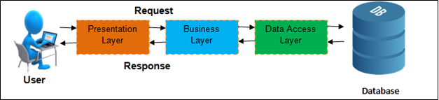

Figure : 3-tier architecture

The three tiers in 3-tier architecture are as follow;

1. **Presentation tier**

It is the top-level tier that shows services’ information accessible on a website. It sends results to browser and other tier in network for its communication with another tier.

1. **Application tier**

It is the middle-tier and also known as business logic tier. Here, application’s functionality is controlled by performing detailed processes.

1. **Data tier**

It is the down-level tier that contains database server (data are stored and retrieved). Data are kept independent of application servers and business logic.

The benefits of using 3-tier architecture are as follows;

1. It separates Presentation tier, Applicated tier and Data tier logically.
2. It helps to enable parallel development of each tier as each are independent of one another.
3. Modification can be easily done.
4. Functionality can be reused.

# 4. Work Breakdown Structure (WBS) / Scheduling

## 4.1 Work Breakdown Structure

Work breakdown structure is defined as the hierarchical structure which reflects the decomposition of work done in the project into manageable sections. It makes project execution simple and understandable. Project’s work is subdivided because of the following reasons;

1. It defines and manages the work of the project.
2. It measures the milestones of the project.
3. It helps in estimation of project cost, time and identifies risk.
4. It indicates the project scope which makes stakeholder to understand easily.
5. It can be used to display and allocate responsibilities.

In my project of Pharmacy management system, its task has also been subdivided and created a work breakdown structure. The main subdivided parts are Project Management, Analysis, Design, Implementation, Testing and Deployment. And these are further divided into sub-division and this are indicted in following WBS chart;

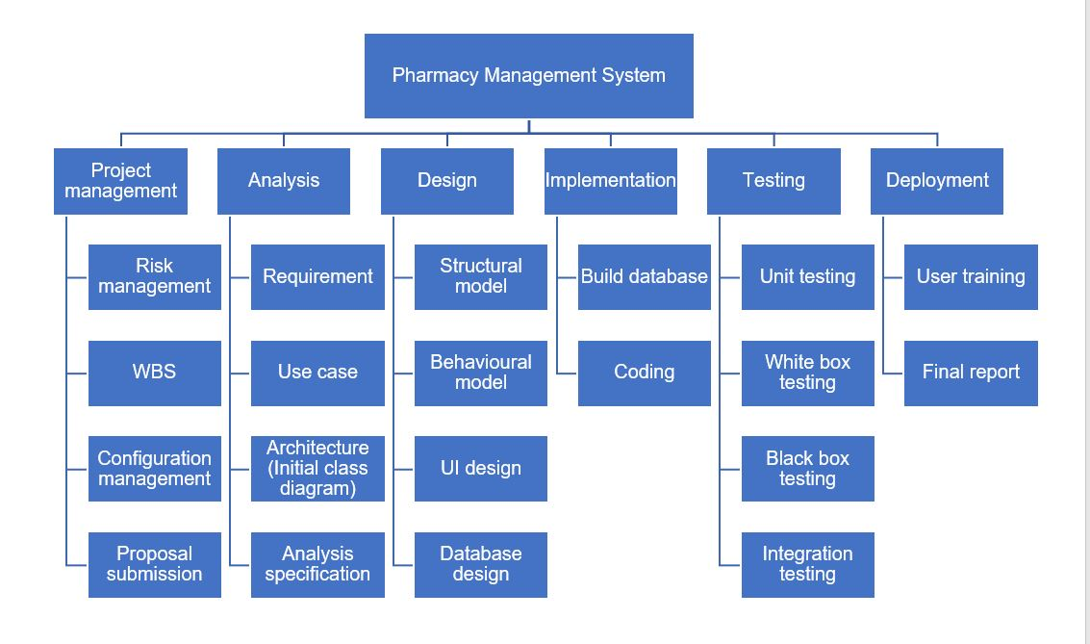

Figure : Work breakdown structure

## 4.2 Milestones

|  |  |
| --- | --- |
| **Milestones** | **Date** |
| **Project Management**  Risk Management  WBS  Configuration Management  Proposal Submission | 21/12/2018 to 03/01/2019  21/12/2018 to 25/12/2018  26/12/2018 to 27/12/2018  28/12/2018 to 31/12/2018  01/01/2019 to 03/01/2019 |
| **Analysis**  Requirement  Use Case  Architecture (Initial Class Diagram)  Analysis Specification | 04/01/2019 to 28/01/2019  04/01/2019 to 14/01/2019  15/01/2019 to 18/01/2019  19/01/2019 to 24/01/2019  25/01/2019 to 28/01/2019 |
| **Design**  Structural Diagram  Behavioral Diagram  UI Design  Database Design (ER, Data Dictionary) | 29/01/2019 to 27/02/2019  29/01/2019 to 03/02/2019  04/02/2019 to 10/02/2019  11/02/2019 to 20/02/2019  21/02/2019 to 27/02/2019 |
| **Implementation**  Build Database  Coding | 28/02/2019 to 31/03/2019  28/02/2019 to 04/03/2019  05/03/2019 to 31/03/2019 |
| **Testing**  Unit Testing  Integration Testing  Blackbox Testing  Whitebox Testing | 01/04/2019 to 10/04/2019  01/04/2019 to 04/04/2019  05/04/2019 to 07/04/2019  08/04/2019 to 08/04/2019  09/04/2019 to 10/04/2019 |
| **Deployment**  User Training  Final Report | 11/04/2019 to 21/04/2019  11/04/2019 to 16/04/2019  17/04/2019 to 21/04/2019 |

**Description of Milestones:**

Milestone is the measure of the project achievements via deadlines.

* **Project Management (14 days)**

The total days allocated for project management is 14 days. And I have allocated for;

* + Risk management – 5 days
  + Work breakdown structure (WBS) – 2 days
  + Configuration management – 4 days
  + Proposal submission – 3 days
* **Analysis (25 days)**

The total days allocated for analysis is 25 days. And I have allocated for;

* + Requirement – 11 days
  + Use case – 4 days
  + Architecture (Initial class diagram) – 6 days
  + Analysis specification – 4 days
* **Design (30 days)**

The total days allocated for design is 30 days. And I have allocated for;

* + Structural model – 6 days
  + Behavioral model – 7 days
  + UI design – 10 days
  + Database design – 7 days
* **Implementation (32 days)**

The total days allocated for implementation is 32 days. And I have allocated for;

* + Build database – 5 days
  + Coding – 27 days
* **Testing (10 days)**

The total days allocated for testing is 10 days. And I have allocated for;

* + Unit testing – 4 days
  + White box testing – 2 days
  + Black box testing – 1 days
  + Integration testing – 3 days
* **Deployment (10 days)**

The total days allocated for deployment is 10 days. And I have allocated for;

* + User training – 6 days
  + Final report – 4 days

## 4.3 Scheduling / Gantt Chart

Scheduling is the project planning which lists the project’s milestones, activities and deliverables that includes start and finish dates of each task in the project. It ensures project’s success, allocate resources and set realistic time-frame.

And scheduling of my project is shown through the following Gantt chart;

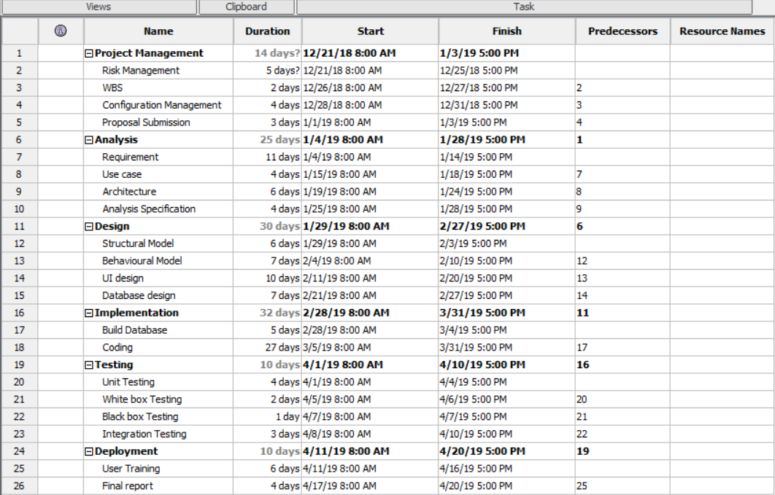

Figure : Gantt chart 1

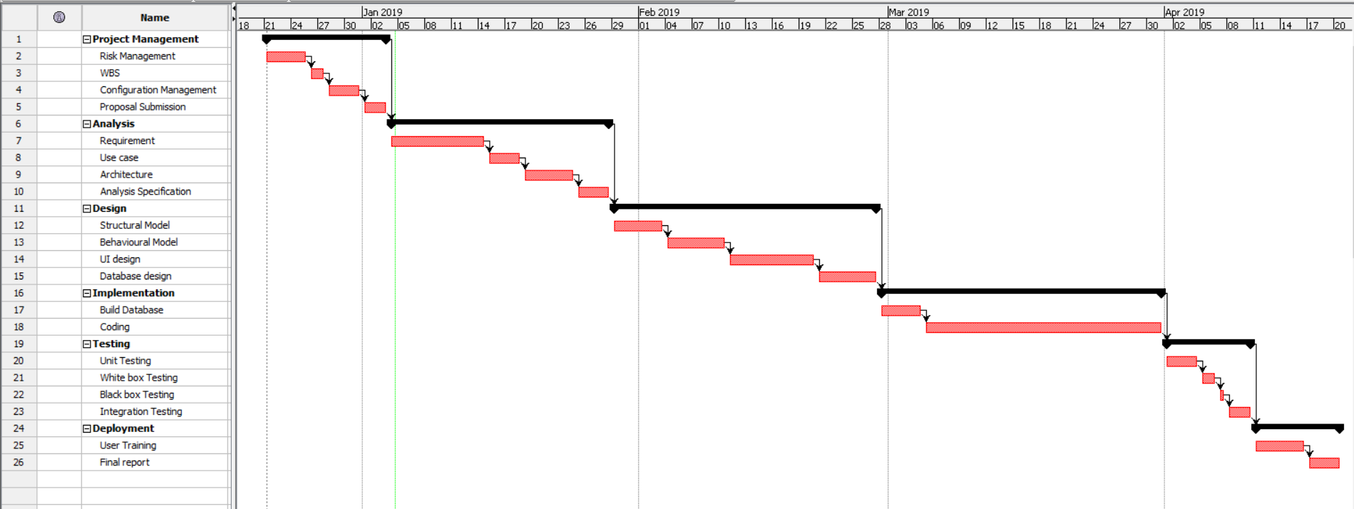

Figure : Gantt chart 2

# 5. Risk Management

Risk management is the identification and prioritization of risks and analyzing with various tools and economical application resources to minimize their impact on the system. It also identifies the possible problem before it arises so as to plan the risk-handling activities. Vulnerability assessment is also another term for risk management.

And risk can be controlled by identifying their likelihood, consequences and impact on the system. To analyze impact of risk, I have used following formula;

Impact = Likelihood * Consequence

Risk Likelihood values are shown as follows

|  |  |
| --- | --- |
| Likelihood | Value |
| Low | 1 |
| Medium | 2 |
| High | 3 |

Risk Consequence values are shown below

|  |  |
| --- | --- |
| Consequence | Value |
| Very low | 1 |
| Low | 2 |
| Medium | 3 |
| High | 4 |
| Very High | 5 |

|  |  |  |  |  |  |
| --- | --- | --- | --- | --- | --- |
| S. No | Risks | Likelihood | Consequences | Impact | Solution |
| 1 | Denial of service attack | 2 | 4 | 8 | Bandwidth must be added in order to handle the spikes in the traffic and make the system DDoS resistant. |
| 2 | Hard disk failure | 1 | 4 | 4 | All the data must be backed up in external drive or in cloud and hard disk must be monitored properly. |
| 3 | Changes of requirement | 3 | 5 | 15 | Requirements must be analyzed properly from the stakeholders before beginning the project. And any changes must be done as per them. |
| 4 | Stakeholder conflicts | 2 | 5 | 10 | Identify powerful and influential stakeholder in order to have correct set of resources and invest. |
| 5 | Fault in Scheduling | 3 | 4 | 12 | Proper schedule planning must be done and make sure none of the task will exceed its deadline. |
| 6 | Power fluctuation | 3 | 3 | 9 | Power spikes results component failure so point of use protector should be implemented in every specific area which provide protection from variance of power supply. |
| 7 | Lack of resources | 1 | 4 | 4 | Before beginning the project, all the resources required must be analyzed and collected. |

# 6. Configuration Management

Configuration management is the way of creating and maintaining steadiness between physical and logical assets in an operational environment throughout project life (WhatIs.com, Configuration management, 2008). For example: consistency of product’s performance, design, operational information etc. It identifies bad configuration changes and ensures quick service restoration.

And the configuration management of my project is successfully created which consists of the directories included in the project. The backup of vital aspects is maintained.

The tree structure of the project is shown below;

# **7. Conclusion of the project**

In conclusion, I have provided the background of my project and identified all the problems by researching in different pharmacy store. The aims and objectives are clearly presented in the proposal and the potential risk has been identified and provided the solutions to overcome those problems. The project has been scheduled using Gantt chart and work breakdown structure is created to understand the project clearly. Suitable development methodology, design pattern and system architecture were implemented for this management system.

# **8. References**

<https://www.tutorialspoint.com/sdlc/sdlc_waterfall_model.htm> [Accessed on 26th Dec,2018]

<https://www.interserver.net/tips/kb/mvc-advantages-disadvantages-mvc/> [Accessed on 26th Dec,2018]

<https://www.techopedia.com/definition/24649/three-tier-architecture> [Accessed on 26th Dec,2018]

<https://c2sconsultinggroup.com/the-importance-of-configuration-management/> [Accessed on 29th Dec,2018]

<https://www.slideshare.net/HabtamuAsmare/pharmacy-management-system-requirement-analysis-and-elicitaion-document> [Accessed on 04th Dec,2019]